**♤SQL ASSINGMENT♤**

**CHETAN BALIRAM GORE**

**Creating table**

CREATE TABLE employees (

emp_id INT PRIMARY KEY,

name VARCHAR(100) NOT NULL,

department VARCHAR(50),

salary DOUBLE,

join_date DATE

);

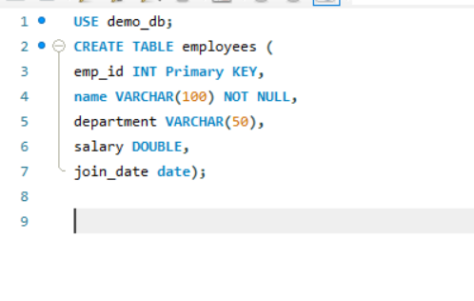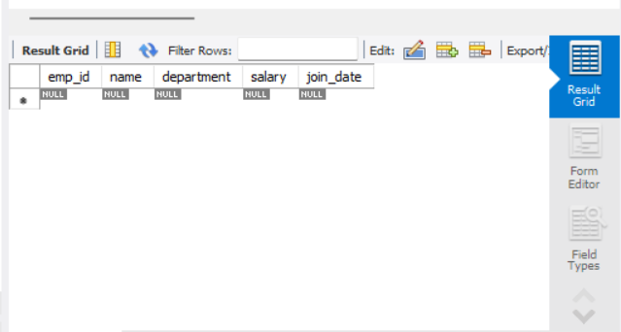

**Insertion of query**

INSERT INTO employees (emp_id, name, department, salary, join_date)

VALUES

(101, 'John Doe', 'HR', 45000, '2021-06-15'),

(102, 'Jane Smith', 'IT', 75000, '2020-01-10'),

(103, 'Alice Johnson', 'Finance', 60000, '2019-08-23'),

(104, 'Bob Brown', 'IT', 80000, '2022-03-01'),

(105, 'Eve Davis', 'Marketing', 55000, '2021-11-05');

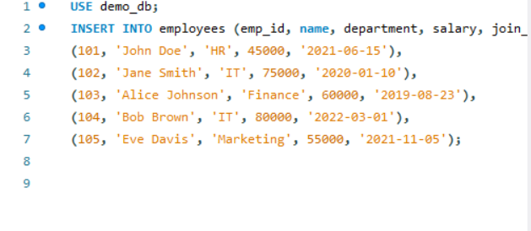

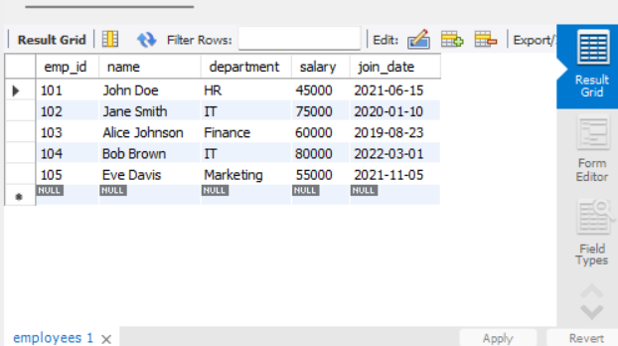

**Selection of query**

1. SELECT * FROM employees;

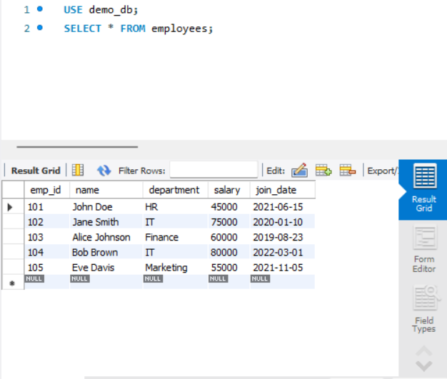

1. SELECT name, department FROM employees;

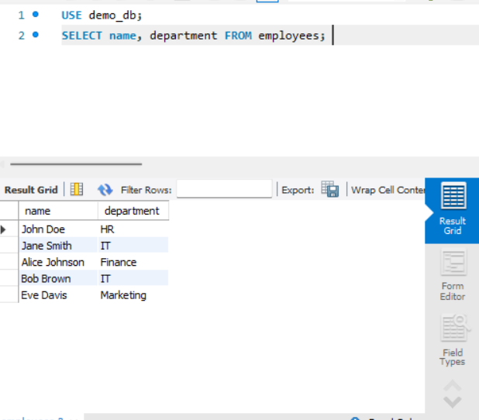

1. SELECT * FROM employees WHERE department = 'IT';

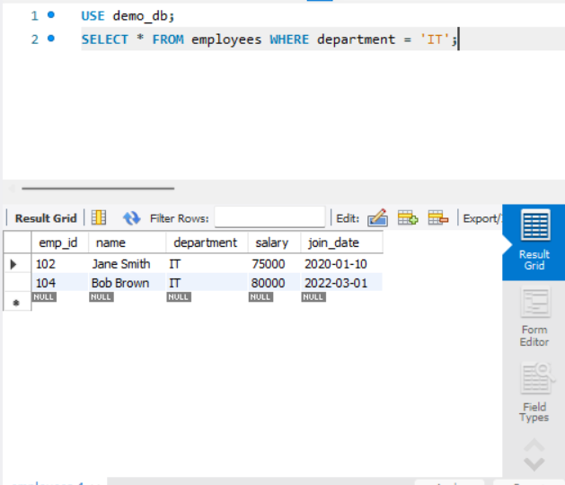

**AND, IN BETWEEN & LIKE**

SELECT * FROM employees

WHERE department = 'IT' AND salary > 75000;

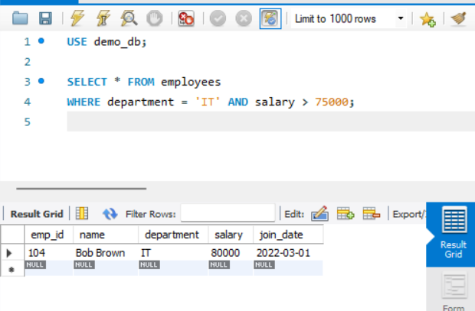

SELECT * FROM employees

WHERE department IN ('IT', 'Finance');

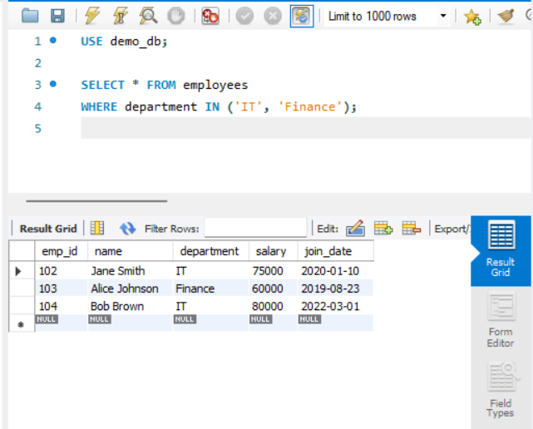

SELECT * FROM employees

WHERE salary BETWEEN 50000 AND 70000;

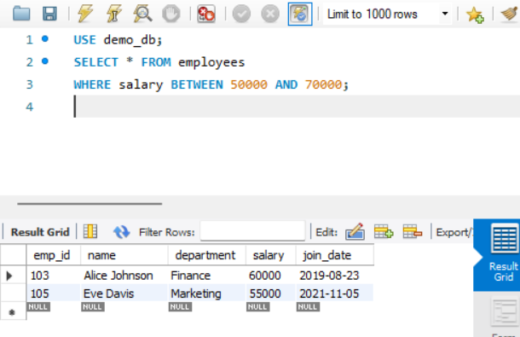

SELECT * FROM employees

WHERE name LIKE 'J%'; -- Names starting with J

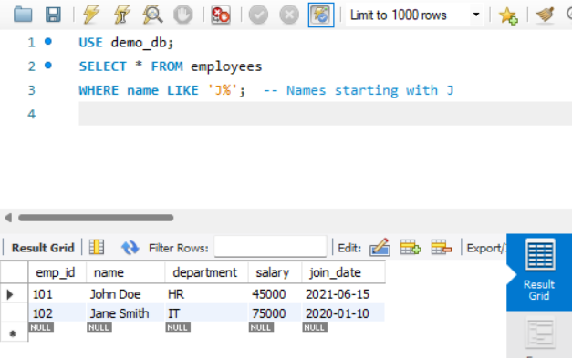

**CLAUSE -ORDER BY, WHERE, HAVING**

SELECT * FROM employees

ORDER BY salary DESC;

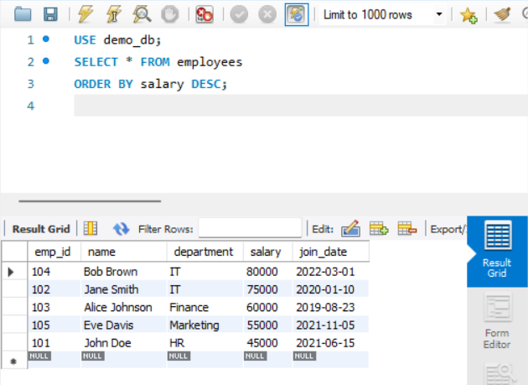

**UPDATE QUERY**

UPDATE employees

SET salary = 82000

WHERE emp_id = 104;

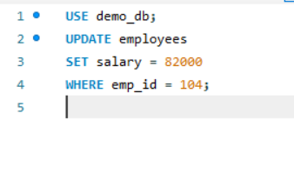

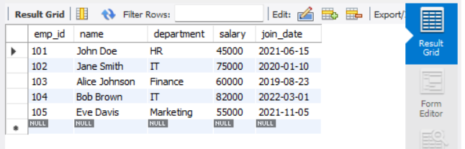

DELETE FROM employees

WHERE emp_id = 105;

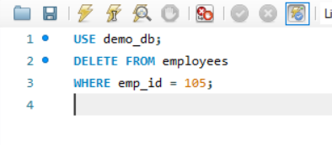

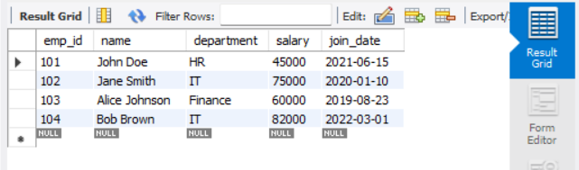

SELECT department, AVG(salary) AS avg_salary

FROM employees

GROUP BY department;

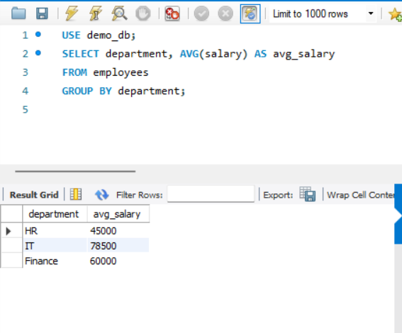

SELECT department, COUNT(*) AS emp_count

FROM employees

GROUP BY department

HAVING COUNT(*) > 1;

